**Document Object Model (DOM) Introduction**

1. **What is DOM**

In addition to parsing the style and structure of the HTML and CSS, the **browser creates a representation of the document** known as the **Document Object Model**. This model allows JavaScript to access the text content and elements of the website **document** as **objects**.

As we run the html on the browser, what showing under Elements tab is the DOM. First, it look exactly the same as the HTML source code we wrote.

1. **The Document Object**

The document object is a built-in object that has many **properties** and **methods** that we can use to access and modify websites.

Although DOM and HTML Source Code seems like a same thing, there are two instances in which the browser-generated DOM will be different than HTML source code:

* The DOM is modified by client-side JavaScript
* The browser automatically fixes errors in the source code (then DOM != Source Code)

Let’s see how we can change some of the live properties of the document object.

+) Submitting document.body to console 🡪 We will get the content encapsulated in <body>

+) Try changing backgruond color: document.body.style.backgroundColor = 'fuchsia';

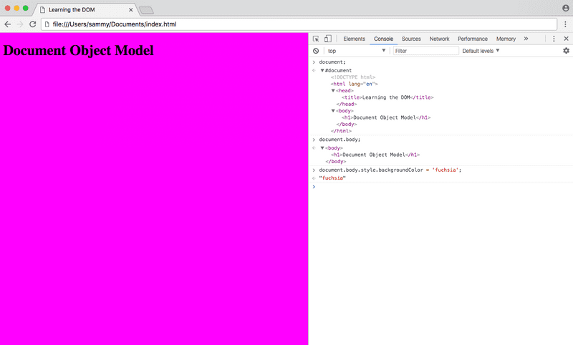

**Note:** In order to change the background-color CSS property, we had to type backgroundColor in the JavaScript. Any hyphenated CSS property will be written in camelCase in JavaScript.

However, the source of the website will not change and will never be affected by client-side JavaScript. If we refresh the page, the new elements added will disappear.

1. **Conclusions**

|  |
| --- |
| In conclusion, our source code is always the same. This is obvious, because anytime we revisit the page (or a different person revisits the page), we want our first appearance to be the same (in most cases).  DOM is modified by client-side, meaning that the way DOM changes is different for different people. This is also true, because we might interact with the website differently.  🡪 Our JavaScript code will interact with the document element, to change the DOM on the client side. |